NAME:Rishik JK
REG.NO :192511052

CSA1702-ARTIFICIAL INTELLIGENCE
LAB EXPERIMENT

26. Prolog Program for Fruits and Their Colors Using Backtracking

1. Aim
To write a Prolog program to represent fruits and their colors and retrieve the colors using backtracking.

2. Algorithm
- Start the program.
- Define facts containing fruit names and their colors.
- Query the fruit-color relationship.
- Use backtracking to find alternative answers.
- Display the fruit and its color.
- Stop.

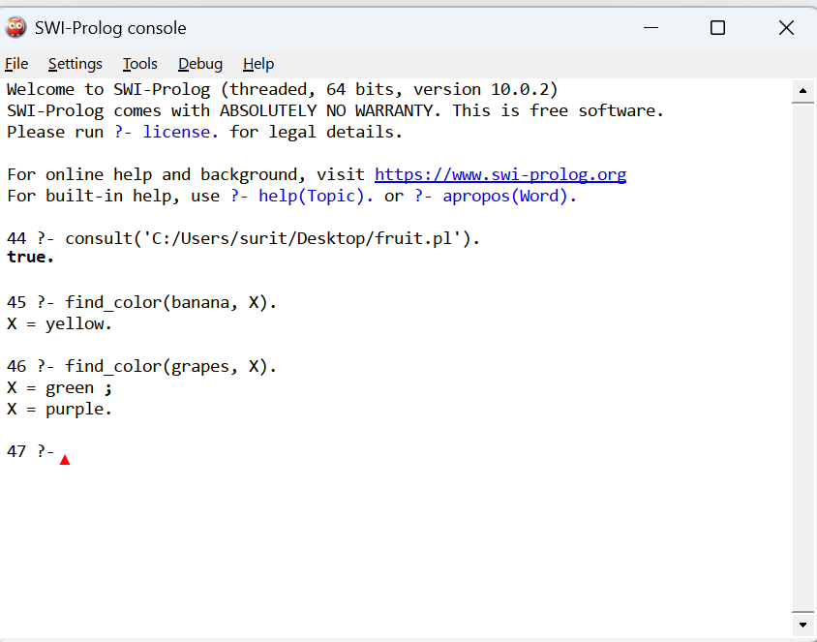

3. Result
Thus, the Prolog program to represent fruits and their colors using backtracking was successfully implemented and executed. Multiple colors of grapes were retrieved using backtracking.

